

**Artificial Intelligence and Data Science Department.**

OOPM / Odd Sem 2021-22 / Experiment 12.

**____________________________________________________________**

YASH SARANG.

47 / D6AD.

EXPERIMENT - 12.

**____________________________________________________________**

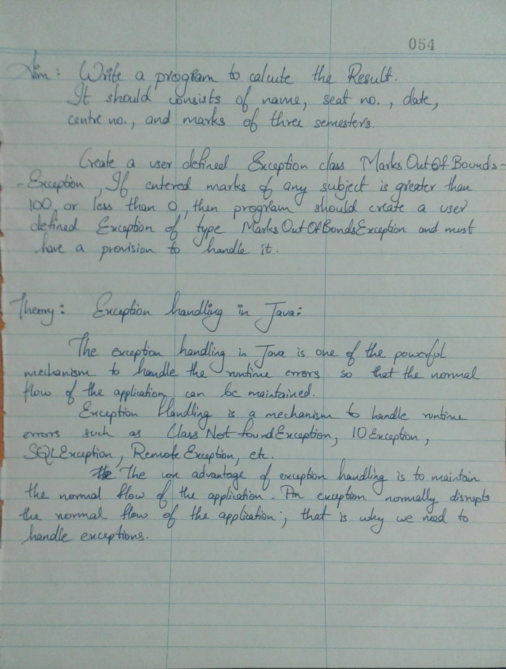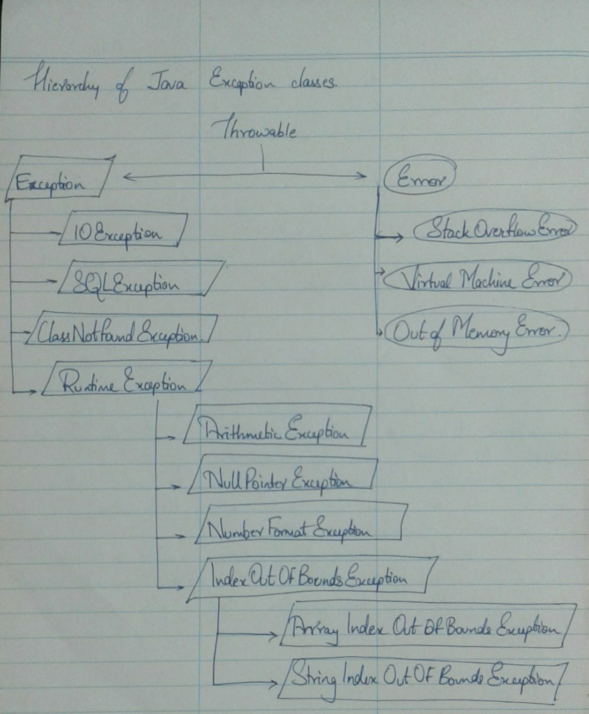

Program Code:

*import java.util.*;*

*import java.lang.*;*

*class MarksOutOfBoundException extends java.lang.Exception*

*{*

*MarksOutOfBoundException(String s)*

*{*

*super();*

*}*

*}*

*class ResultException*

*{*

*String name;*

*int roll;*

*String date;*

*int centerNo;*

*int marks1;*

*int marks2;*

*int marks3;*

*void enteringInfo(String name,int roll,String date,int centerNo,int marks1,int marks2,int marks3)*

*{*

*this.name = name;*

*this.roll = roll;*

*this.date = date;*

*this.centerNo = centerNo;*

*this.marks1 = marks1;*

*this.marks2 = marks2;*

*this.marks3 = marks3;*

*}*

*static void checkForException(int marks) throws MarksOutOfBoundException*

*{*

*if(marks<0||marks>100)*

*throw new MarksOutOfBoundException("Enter a valid marks between 1 and 100");*

*}*

*public static void main(String[] args)*

*{*

*ResultException[] obj = new ResultException[30]; //for creation of objects*

*int objIndex = -1; //for navigating through the objects*

*int choice = 0; //To repeatedly take the entries of the students*

*String n;*

*int r;*

*String d;*

*int c;*

*int m1;*

*int m2;*

*int m3;*

*Scanner sc = new Scanner(System.in);*

*do*

*{*

*++objIndex;*

*obj[objIndex] = new ResultException(); //New object created*

*//getting the name*

*System.out.println("\nEnter the name of the student");*

*n = sc.nextLine();*

*//getting the roll number*

*System.out.println("\nEnter the roll number of the student");*

*r = sc.nextInt();*

*sc.nextLine(); //To consume the stray white space*

*//getting the date*

*System.out.println("\nEnter the date in the format: 25th July");*

*d = sc.nextLine();*

*//getting the centre number*

*System.out.println("\nEnter the centre number");*

*c = sc.nextInt();*

*sc.nextLine(); //To consume the stray white space*

*//Getting marks*

*System.out.println("\nEnter the marks(between 1 and 100) for the first subject: ");*

*m1 = sc.nextInt();*

*System.out.println("\nEnter the marks(between 1 and 100) for the second subject: ");*

*m2 = sc.nextInt();*

*System.out.println("\nEnter the marks(between 1 and 100) for the third subject: ");*

*m3 = sc.nextInt();*

*sc.nextLine(); //To consume the stray white space*

*try*

*{*

*checkForException(m1);*

*checkForException(m2);*

*checkForException(m3);*

*}*

*catch(MarksOutOfBoundException e)*

*{*

*System.out.println("\nError: " + e);*

*System.out.println("Enter the details again");*

*--objIndex;*

*choice = 1;*

*continue;*

*}*

*obj[objIndex].enteringInfo(n,r,d,c,m1,m2,m3);*

*System.out.println("\nThe entered info is -> \nName: " + obj[objIndex].name + "\nRoll*

*number: " + obj[objIndex].roll + "\nDate: " + obj[objIndex].date + "\nCentre number: " +*

*obj[objIndex].centerNo + "\nMarks in Subject1: " + obj[objIndex].marks1 + "\nMarks in Subject2: " +*

*obj[objIndex].marks2 + "\nMarks in subject3: " + obj[objIndex].marks3 );*

*System.out.println("\nIf you want to add a new entry enter 1");*

*choice = sc.nextInt();*

*}while(choice == 1);*

*System.out.println("\nExiting");*

*}*

*}*

**____________________________________________________________**

**The output of the program :**



